Poatina Community
Learning Together
Justice and Advocacy (Part 1)

Introduction

On January 27, 2019 we as a community ran a Terra Populous event. Below, you will see the article that The Examiner ran 5 days before the event. It speaks to some of the intent that we had as a community for putting on the event.

A part of our intent - which was not for public and marketing purposes - was to position ourselves (to ourselves and our publics) as a community that empathises with and speaks up for justice and provides space and opportunity for 'voice' to be heard.

Reflect 1
- From what we experienced on the day, in what ways did this event help us to achieve this intent?
- In terms of advocacy, what do think the success factors were, or could have been?

As a reminder, this is an important footnote about our public messaging. (This was circulated to the community the day before the event in order to help us respond to questions about Terra Populous)

These few key messages are a guide to assist when explaining to our guests and friends about what is happening over this weekend and in the future. Use your own words, but these are the key concepts.

- The Poatina community has decided to replace its traditional Australia Day Festival with a new district event in Poatina, commencing in late summer 2020.
  - There is a flyer explaining this in more detail. Please give this to people who are interested. It will also be handed out at the grid on Sunday
  - If you need more information about the 2020 thinking, please feel free to discuss with the leadership team or those involved in the 2020 working group (McKanes, Heidi, Keith, Steve & Hannah, John & Marg)
- Terra Populous is NOT a replacement for our Australia Day event NOR a statement about how the community views Australia Day.
- Terra Populous IS an attempt by the Poatina community to stand with and find a way to celebrate together the Ancient/first peoples, European and new communities’ stories in a way that honours all.

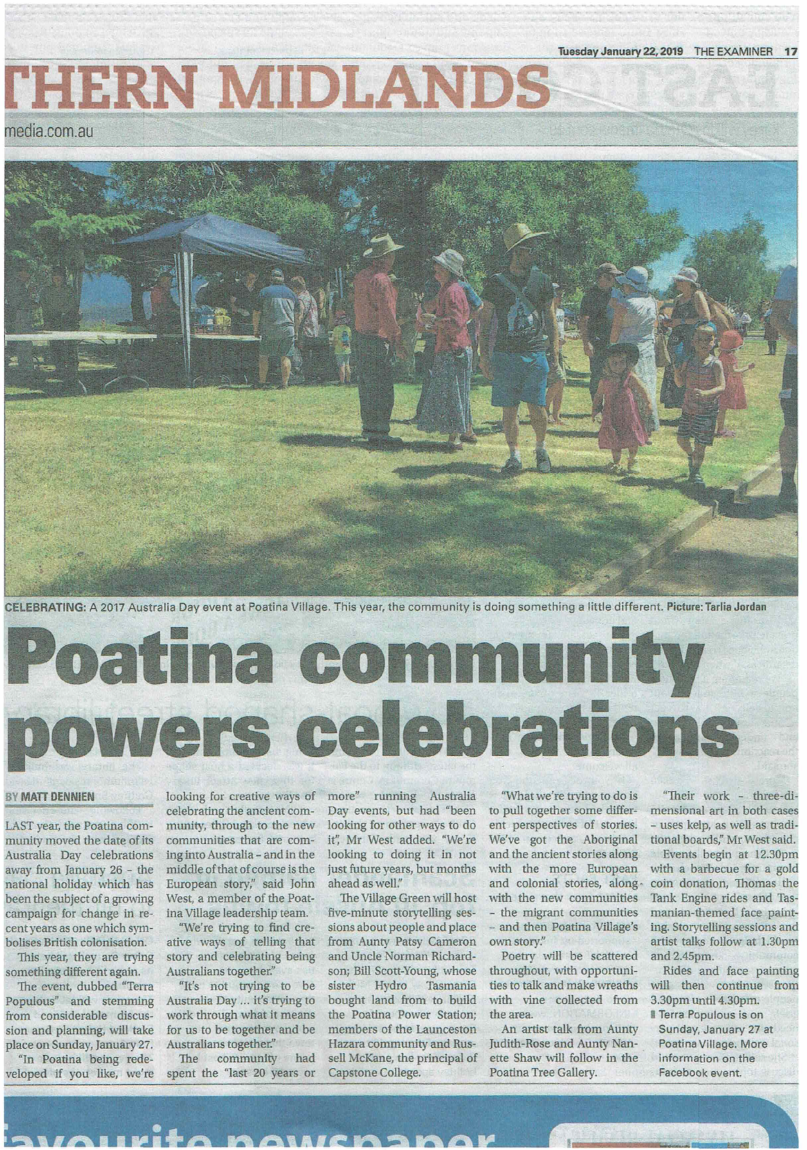

Reflect 2

- Is it right and appropriate that we as Poatina Community actively seek ways of expressing ourselves in this way?
- If it is appropriate, what other opportunities/ideas present themselves for us to explore?
- What should be the selection criteria for choosing what advocacy approach/es we take?

Luke Morgan wrote this about Terra Populous in the February 2019 Learning Together piece:

Reaching Out/An Outward Focus (part2)
I find a similar resonance with Terra Populous. The principles and values that informed and guided the day resonate with those that found expression in the first Australia Day celebration in 1995. But what a lot has changed in society (and in Poatina Village) in the last 24 years! Terra Populous, I believe, gave expression to the principles and values of our past, spoke into (and I hope challenged) our present society and its prevailing values, and, I believe, brought a prophetic contribution in that it pulled us and perhaps others towards the future.
It felt kind of like a gathering of extended family to me; perhaps a tribe (from many different backgrounds) that are committed to the values and principles that we as a community are seeking to embody. I was fascinated that the clearest reference to ‘God’ came not from someone from Poatina but from a person of Muslim heritage. It seemed to be a living demonstration of what Bono from U2 was trying to express in his quote “we are one but not the same”.
Tom (N. T.) Wright, in his books Simply Christian and Surprised by Hope, suggests there are three broad elements of somewhere where God’s Kingdom is at work, or where values and principles inherent in the Judeo-Christian world view are central. They are: Relationships Restored, Justice Re-established, and Beauty Rediscovered. I believe that each of these were visible during Terra Populous, and, using Wright’s framework, I was fascinated by what I would call the Kingdom network that gathered on the day, and by what we achieved. As we continue to reach out to our region and state, whether through education or events, and even as we look ahead to summer celebrations in 2020, I wonder what forms the expression of these elements may take.

Reflect 3

So now - all this begs the question - What do we mean by these terms - advocacy, justice, shalom, equity, voice, prophetic?

In part 2 of this Learning Together section on Justice and Advocacy we'll unpack the meanings, solutions and actions more fully, but for now we'll take the meaning from the heart of all of these notions to be:

Making the world a fairer and more equitable place

Many people, of all nations, cultures, life stage and faiths (and those who say they have no faith) strive to make the world a better place. Although the source of that motivation may be many and varied, it seems that care for those who are doing life tough is an inherently human characteristic. Mind you, it seems that that concern is often selectively applied and our recognition of those who are in need blinkered! We all have our blind spots and we all can overlook those in need around us.
But at the Christian heart of justice is the loving and just heart of God as expressed in the Biblical passages in Amos 5:24 and Micah 6:8 (respectively)

"Let justice roll down like waters,
and righteousness like an ever-flowing stream." (NASB)

"He has told you, human one, what is good and what the Lord requires from you -
to do justice, embrace faithful love, and walk humbly with your God." (CEB)

What does a fair world look like and what is Poatina Community's place and responsibility in it?

What follows is a small list of key areas we can ask ourselves about - where do we fit and what do we (Poatina Community) want to do about it? Often these questions are asked in the big global context…but they are just as relevant for a village and community like Poatina.

- Who will be helped? - in practical terms who are the 'poor' and 'vulnerable' we are talking about?
- What is our foreign policy and how can Poatina Community influence the shape and focus of it?
- How do we get our own (Australia's, Tasmania's, Poatina's) social change in order?
- God has a plan for a social order that is fair and equitable - what is it and how do we align with it?
- Alternatives to the weaknesses and inequities of market economies
  - Capital for the poor - small enterprise loans
  - Government focus
  - How we measure social and economic well-being
  - What is the 'good life' - and who gets to define it?
- Unmanageable Debt
- Preserving the Earth and enabling the poor
  - Renewable energy
  - Alternatives to 'costly' transport
  - Waste management
  - Land and forest nurture and improvement
  - Carbon
- What about foreign aid - does it help?
- How do we as Poatina Community make a difference - beyond the cattle grid?

Let justice roll down like waters

A discussion starter
Prepared by John West
June 2019

